
Faculty of Computers and Information Technology (FCIT)
An Intelligent Search and Rescue System to Detect Lost Humans in The Desert

Authors:
Faisal Al-anzi, SID: 421002959
Meshal Al-anzi, SID: 421007547
Abdulaziz Al-anzi , SID: 421008328
Alwaleed Alshammari, SID: 411003557
Ahmad Alatawie, SID: 411006424

Supervisor: Dr. Mohammed Al-Atwi
Submitted in partial fulfilment of the requirements for the Degree of Bachelor of Computer Science at University of Tabuk

Academic Year: 2024/2025

DECLARATION
I hereby declare that this project report is based on my original work except for citations and quotations which have been duly acknowledged. I also declare that it has not been previously and concurrently submitted for any other degree or award at University of Tabuk or other institutions.

Name | ID No. | Signature
Faisal Al-anzi | 421002959 | 421002959
Meshal Al-anzi | 421007547 | 421007547
Abdulaziz Al-anzi | 421008328 | 421008328
Alwaleed Alshammari | 411003557 | 411003557
Ahmad Alatawie | 411006424 | 411006424

Date: _________________________

APPROVAL FOR SUBMISSION
I certify that this project report entitled “An Intelligent Search and Rescue System to Detect Lost Humans in The Desert” was prepared by Faisal Alanzi, Meshal Hussin Al-anzi, Abdulaziz Al-anzi, Alwaleed Alshammari, and Ahmad Ali Alatawie has met the required standard for submission in partial fulfilment of the requirements for the award of Bachelor of Computer Science at University of Tabuk.

Approved by,

Signature : _________________________
Supervisor : Dr. Mohammed Al-Atwi
Date : _________________________

The copyright of this report belongs to the author and is protected under the intellectual property right laws and conventions. It can only be considered/used for purposes like extension for further enhancement, product development, adoption for commercial/organizational usage, etc., with the permission of the University of Tabuk.

© 2024, The AI Group. All right reserved.

ACKNOWLEDGEMENTS
I would like to thank everyone who had contributed to the successful completion of this project. I would like to express my gratitude to my research supervisor, Dr. Mohammed Al-Atwi for his invaluable advice, guidance and his enormous patience throughout the development of the research.
In addition, I would also like to express my gratitude to my loving parent and friends who had helped and given me encouragement.

ABSTRACT
The harsh and expansive terrain of desert environments presents significant challenges for search and rescue operations aimed at locating lost individuals. Traditional methods often rely on human search teams and helicopters, which are resource-intensive and time-consuming. In response to these challenges, this study proposes an intelligent search and rescue system leveraging advanced technologies to enhance detection and localization of lost humans in desert regions.
The system integrates various components, including thermal imaging sensors, and an Aartificial intelligence (AI) algorithm for data processing and decision-making. airborne patrol predefined search areas, capturing real-time imagery and thermal data. This data is transmitted to a central command centre where the AI algorithm processes it to identify potential human targets based on thermal signatures, body shapes, and movement patterns.
The proposed system offers several advantages over traditional search and rescue methods. It reduces reliance on manpower and costly resources by employing airborne equipped with advanced sensors. Additionally, the integration of AI enhances the efficiency and effectiveness of search operations by rapidly analysing vast amounts of data to identify potential targets. Moreover, the system's adaptability to varying environmental conditions and terrain complexities enhances its applicability across different desert landscapes.

TABLE OF CONTENTS

DECLARATION ii
APPROVAL FOR SUBMISSION iii
ACKNOWLEDGEMENTS v
ABSTRACT vi
TABLE OF CONTENTS vii
LIST OF TABLES ix
LIST OF FIGURES x
LIST OF ABBREVIATIONS xi

CHAPTER

CHAPTER 1 1
1 INTRODUCTION 1
1.1 Introduction 1
1.2 Background 1
1.3 Problem overview 2
1.4 Project Aim 3
1.5 Project Objectives 3
1.6 Report’s Layout 4
1.7 Summary 4
CHAPTER 2 5
2 BACKGROUND AND RELATED WORKS 5
2.1 Introduction 5
2.2 Project Overview 5
2.3 Existing Algorithms 7
2.4 Object detection methods 9
2.5 Summary 10
CHAPTER 3 11
3 METHODOLOGY 11
3.1 Introduction: 11
3.2 Waterfall sequential phases: 11
3.3 Summary 13
3 CHAPTER 4 14
3 SYSTEM DESIGN 14
4.1 Introduction 14
4.2 System process 14
4.4 software environment 17
4.5 Summary 18
3 CHAPTER 5 19
3 RESULTS 19
5.1 project interface 19
5.2 project database 21
5.3 project code 21
CHAPTER 6 25
3 CONCLUSION AND RECOMMENDATION 25
6.1Conclusion 25
6.2 Students reflection 25
6.3 Recommendation 25
REFERENCES 26

LIST OF TABLES

TABLE TITLE PAGE
Table 2- 1:Object detecion methods 9

LIST OF FIGURES

FIGURE TITLE PAGE
Figure 2-1:CNN algorithm[9] 7
Figure 2- 2:YOLO algorithm [10] 8
Figure 2-3: yolo v2 architecture [11] 8
Figure 2-4: yolo v3 architecture[12] 9

Figure3- 1: Waterfall method [16] 11
Figure4- 2:System Process 14
Figure4-3:The network architecture of YOLOv3[18] 16

Figure4- 1:Python logo 17

Figure5- 1:Home page 19
Figure5- 2: CNN algorithm page 20
Figure5- 3:YOLO algorithm page 20
Figure5- 4:List of the COCO Object Classes 21
Figure5- 5:Import libraries code 22
Figure5- 6:Interface code 22
Figure5- 7:Upload image code 23
Figure5- 8:CNN algorithm code 23
Figure5- 9:YOLO code 24

LIST OF ABBREVIATIONS
AI Artificial Intelligence
GPS Global Positioning System
HOG Histogram of Oriented Gradients
SIFT Scale-Invariant Feature Transform
NN Neural Networks
CNN Convolutional Neural Networks
R-CNN Region Convolutional Neural Network
YOLO You Only Look Once
ResNet Dynamic Link Library
USB Universal Serial Bus
PVT Position, Velocity and Time
YOLO You Only Look Once
NMEA National Marine Electronics Association
OID Open Images Dataset

INTRODUCTION

Introduction
This chapter explains the main concept of our project such as background, problem overview, research aim, research objectives, and report layout.

Background
Desert environments pose unique and formidable challenges for search and rescue operations due to their vast expanses, extreme temperatures, and rugged terrain. Locating lost or stranded individuals in such harsh conditions often requires extensive resources and poses significant risks to rescue teams. Traditional methods relying on manual search efforts and aerial reconnaissance have limitations in effectively covering large desert areas while also being time-consuming and resource-intensive [1].
In response to these challenges, there is a growing need for innovative technologies and strategies to enhance the efficiency and effectiveness of desert search and rescue missions. This introduction outlines the concept of an intelligent search and rescue system designed specifically to detect lost humans in desert environments.
The proposed system integrates cutting-edge technologies such as airborne, and AI algorithms to improve the detection and localization of individuals in distress. By combining aerial surveillance with AI-driven data processing, the system aims to streamline search operations, reduce reliance on manpower, and expedite response times [2].
This introduction provides an overview of the key components and functionalities of the intelligent search and rescue system, highlighting its potential benefits and contributions to enhancing desert search and rescue capabilities. Additionally, it underscores the importance of leveraging technology and innovation to address the unique challenges posed by desert environments and improve the outcomes of search and rescue missions [3].

Problem overview
Desert environments present a myriad of challenges for search and rescue operations, making the task of locating lost or stranded individuals a complex and daunting endeavour [4]. Several key factors contribute to the difficulty of conducting effective search and rescue missions in desert regions:
- Vast and Harsh Terrain: Deserts are characterized by expansive and rugged terrain, often with limited accessibility due to sand dunes, rocky outcrops, and sparse vegetation. Navigating through such environments can be arduous and time-consuming, hampering search efforts.
- Extreme Weather Conditions: Desert regions are known for their extreme temperatures, with scorching heat during the day and plummeting temperatures at night. These harsh weather conditions not only pose risks to the safety of individuals in distress but also present challenges for search teams operating in such environments.
- Limited Resources and Infrastructure: Desert regions are typically sparsely populated and lack infrastructure, making it challenging to deploy adequate resources and support for search and rescue operations. Limited access to water, fuel, and shelter further complicates rescue efforts and increases the logistical challenges faced by search teams.
- Time Sensitivity: The harsh conditions of desert environments necessitate timely rescue responses, as individuals can quickly succumb to dehydration, heatstroke, or hypothermia. However, the vastness of desert landscapes and the unpredictability of terrain make it difficult to conduct rapid and comprehensive search operations.
- Ineffective Search Methods: Traditional search methods relying on manual ground searches and aerial reconnaissance have limitations in effectively covering large desert areas. These methods are often labor-intensive, time-consuming, and prone to human error, resulting in delays and inefficiencies in locating lost individuals.
- Lack of Real-time Data Analysis: Conventional search and rescue operations may suffer from delays in processing and analyzing collected data, leading to missed opportunities for timely detection and response. Without real-time data analysis capabilities, search teams may struggle to prioritize search areas and make informed decisions during critical rescue operations.

Addressing these challenges requires innovative approaches that leverage advanced technologies such as AI algorithms. By integrating these technologies into a cohesive intelligent search and rescue system, it becomes possible to enhance the efficiency, accuracy, and timeliness of desert search and rescue operations, ultimately improving the chances of locating and rescuing lost individuals in these challenging environments.

Project Aim
The main aim of our project is to develop machine leaning model helps find lost people in desert as real time based on machine learning algorithms.

Project Objectives
There are the main objectives of our project:
- To investigate similar systems related to search and rescue.
- To design an algorithm for detecting lost humans by Image processing technique.
- To develop different algorithms to find lost people.

Report’s Layout
There are four chapters in the report:
- The first chapter is introduction consist of project overview, problem, aims and objectives.
- The second related work chapter discusses previous work related to our project idea.
- The third chapter discusses methodology and how apply the project idea.
- The fourth chapter shows the system design for our project.

Summary
As summary, we understand the project idea, and why we select this idea to do it as graduated project. Hence, we provide crucial idea for helping lost people in desert using modern technological and machine learning.

BACKGROUND AND RELATED WORKS

Introduction
In this chapter, we show six websites which they interested in learning English lessons, the main objectives from this chapter are related to know the main advantages and problems for current systems that concerned in our project idea to learn how improving our idea and build strong website with high features.

Project Overview
In computer vision, several techniques based on feature extraction. Histogram of oriented gradients (HOG) and scale-invariant feature transform (SIFT) [5] are examples of the techniques that have been widely used for object detection.
Currently, AI is the key-trend for object detection. Neural networks (NN) have been exploited to implement computer vision algorithms using machine learning concept. Several algorithms based on NN have been proposed targeting object detection where objects are classified and then localized within the image by drawing a bounding box around the object of interest. Recently, convolutional neural networks (CNN) have been deployed to classify images. Image classification using CNN results in assigning a label to an input image from a fixed set of predefined classes.
Mainly, an image is labeled according to the most dominating object in the image. However, images could include multiple objects. Hence, one label is not sufficient. In addition, detection imposes localizing the objects within the image. A spatial region (coordinates and size) of each object is required [6].
Several techniques have been proposed to make use of the CNN in object detection. These techniques offer detecting of multiple objects in images while generating the information of their bounding boxes [7].
Object detection methods are classified into two categories:
(1) one stage models
(2) two stage models.
In two-stage models, region proposals are determined in the first stage and image classification in the second stage in [8], sliding window approach has been utilized in region proposal stage. Later, classifiers are applied on windows at different locations with different scales. In [9], region convolutional neural network (R-CNN) has been introduced to detect objects in images. R-CNN method generates about 2000 region proposals in the image using selective search method [9]. This technique reduces the number of regions needed when adopting sliding window methods. However, after running classification in all regions, post-processing is needed to refine the bounding boxes, eliminate duplicates and adjust the detection scores.
These operations increase the complexity of the method. R-CNN suffers from space and time cost during training. Also, a limitation of slow detection is imposed. Other enhanced versions of R-CNN have been introduced such as fast R-CNN and faster R-CNN [9] which form a leap towards real-time detection.
In [10], You Only Look Once (YOLO) has been introduced. Instead of exploiting available classifiers to detect objects in various locations in an image, object detection is treated as a single regression issue in the YOLO technique, which goes straight from image pixels to bounding box coordinates and class probabilities [11]. It does not iterate the classification in different regions of an image. Indeed, YOLO forms a unified model of all phases on a neural network. The input image including the object(s) to be detected, passes forward through a single neural network of multiple layers. The method directly produces predictive vectors corresponding to each object occurring in the input image including the corresponding coordinates of its bounding box and class probabilities.
Since it has been released [10], several versions of YOLO have been introduced. In [11], YOLOv2 has been proposed an improved model of YOLO by replacing the backbone network with a simpler Darknet-19 and by eliminating the fully connected layers at the end. In [12], the authors have introduced YOLOv3, which is another improved detector based on YOLO.
The feature extractor in YOLOv3 adopts a hybrid architecture based on Darknet-53 and Residual networks (ResNet). Also, YOLOv3 makes detections at 3 different scales to enable detection of small objects [13] [14].

Existing Algorithms

CNN algorithm
CNN is a deep learning technology that is used to classify images. CNN takes an image as input, assigns learnable weights to it, extracts feature or objects from it, and uses them to differentiate one image from another. It is referred to as ConvNet. The ConvNet's operating principle is to compress images to a format that is easier to process [9].
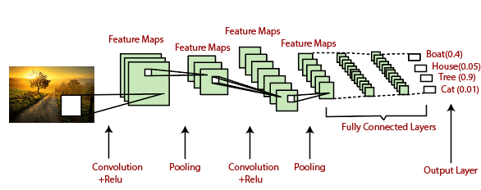
Figure 2-1:CNN algorithm[9]

YOLO algorithm
The basic idea behind YOLO is to divide the input image into a grid of cells and, for each cell, predict the probability of the presence of an object and the bounding box coordinates of the object. The process of YOLO can be broken down into several steps[10]:

1. Input image is passed through a CNN to extract features from the image.
2. The features are then passed through a series of fully connected layers, which predict ‌class probabilities and bounding box coordinates.
3. The image is divided into a grid of cells, and each cell is responsible for predicting a set of bounding boxes and class probabilities.
4. The output of the network is a set of bounding boxes and class probabilities for each cell.
5. The bounding boxes are then filtered using a post-processing algorithm called non-max suppression to remove overlapping boxes and choose the box with the highest probability.
6. The final output is a set of predicted bounding boxes and class labels for each object in the image.
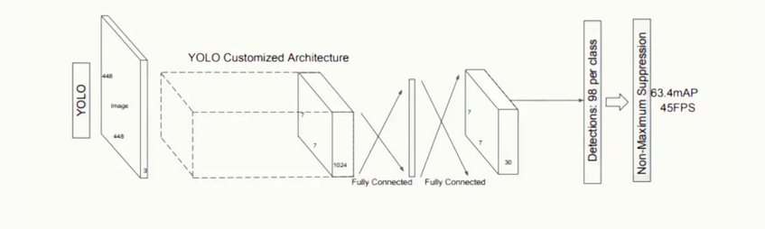
Figure 2- 2:YOLO algorithm [10]

YOLO2 algorithm

The introduction of anchor boxes is one of the most notable distinctions between YOLO v2 and the original. In YOLO v2, CNN predicts both the bounding box coordinates and the anchor boxes. Anchor boxes are pre-defined boxes of varied aspect ratios and scales, which are used to match the predicted bounding boxes with the actual objects in the image. This improves YOLO v2's ability to handle objects of various shapes and sizes. [11].
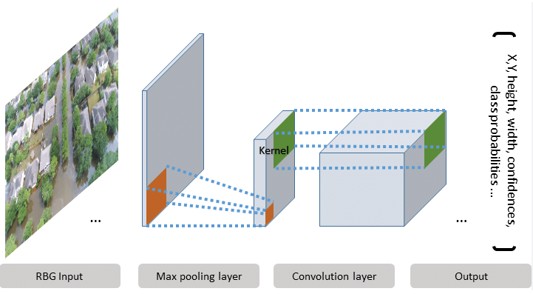
Figure 2-3: yolo v2 architecture [11]

YOLO3 algorithm

YOLO v3 is the third iteration of the YOLO object detecting algorithm. The first distinction between YOLO v3 and prior versions is the presence of several scales in the input image. YOLO v3 extracts features from images at various scales using a technique known as "feature pyramid network" (FPN). This enables the model to detect items of varying sizes within the image.[12][13].

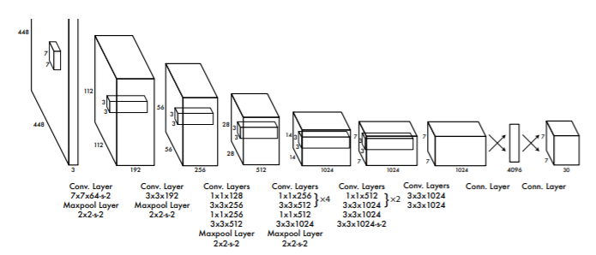
Figure 2-4: yolo v3 architecture[12]

Object detection methods
Based on ref [4-14], we summarize the description about these methods as follow table:
Table 2- 1:Object detecion methods
Technique | Description
HOG | HOG is a technique widely used for object detection in computer vision.
SIFT | SIFT is another technique commonly used for object detection.
NN | NN have been utilized in implementing computer vision algorithms for object detection using machine learning concepts.
CNN | CNN have been deployed for image classification and object detection, resulting in assigning labels and localizing objects within images.
Two-stage Models | Object detection methods classified into two-stage models, where region proposals are determined in the first stage and image classification in the second stage.
R-CNN | R-CNN generates region proposals in images using selective search method, followed by classification and post-processing.
Fast R-CNN | An enhanced version of R-CNN, which reduces time and space cost during training and improves detection speed.
Faster R-CNN | Another improved version of R-CNN that further enhances detection speed and efficiency.
YOLO | YOLO treats object detection as a single regression issue, going directly from image pixels to bounding box coordinates and class probabilities.
YOLOv2 | An improved model of YOLO, replacing the backbone network with a simpler Darknet-19 and eliminating fully connected layers.
YOLOv3 | Another improved version of YOLO, adopting a hybrid architecture based on Darknet-53 and ResNet, making detections at different scales for small objects.

Summary
As summary, the study explains overview about our project, and various exciting systems which are related of our idea. These details make us understand main features for the current systems to make clear features for our project.

METHODOLOGY

Introduction:
In this chapter, we explore the application of the waterfall method in the development of an intelligent search and rescue system for desert environments. The waterfall method offers a structured approach that guides the sequential progression of project phases, from requirements gathering to deployment. By adhering to this methodology, the project benefits from thorough planning, risk mitigation, and clarity in roles and responsibilities.

Waterfall sequential phases:
Applying the waterfall method to your project, including the new information and the entire scope, would involve breaking down the development process into sequential phases. Here's how you can organize it:
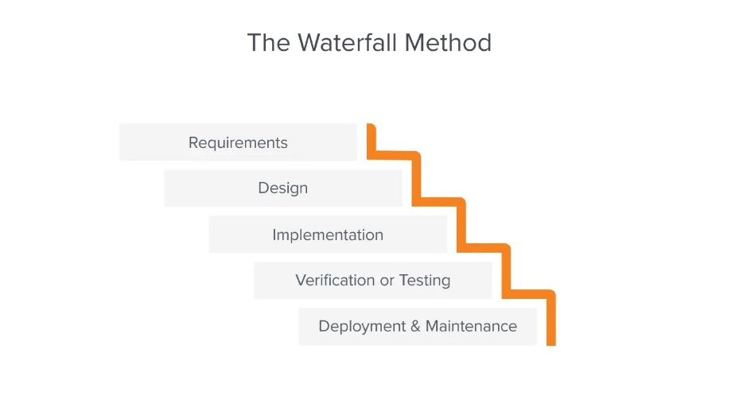
Figure3- 1: Waterfall method [16]

Requirements Gathering:
- Define the objectives and scope of the project, focusing on leveraging AI and drones for search and rescue operations in desert environments.
- Identify key stakeholders, project constraints, and success criteria.
- Gather requirements for the system design, including hardware components, AI algorithms, and communication modules.

System Design:
  - Develop a detailed system architecture based on the gathered requirements and project objectives.
  - Define the roles and responsibilities of each component, including the camera, AI computing device, controller, GPS receiver module, and long-range transceiver.
  - Determine the data flow between components and establish communication protocols.
  - Specify the process for creating and utilizing supervised datasets for training the AI algorithms.

Implementation:
  - Develop and assemble the hardware components, including the camera, AI computing device (utilizing transfer learning for YOLOv3), Arduino NANO controller, GPS receiver module, and RFD900 long-range transceiver.
  - Implement the AI algorithms for human detection using YOLOv3 and transfer learning techniques.
  - Integrate the hardware and software components according to the defined system architecture.

Testing:
  - Conduct rigorous testing of the integrated system in simulated desert environments.
  - Validate the performance of the AI algorithms for human detection and the functionality of the communication modules.
  - Identify and address any technical issues or discrepancies discovered during testing.

Deployment:
  - Deploy the system in real-world desert environments, following the established deployment plan.
  - Provide training to search and rescue personnel on how to use and operate the system effectively.
  - Ensure proper maintenance and support mechanisms are in place for ongoing operation.

Maintenance and Support:
  - Provide ongoing maintenance and support for the deployed system, addressing any issues or updates as needed.
  - Collect feedback from users and stakeholders to identify areas for improvement and optimization.
  - Continuously monitor system performance and make adjustments as necessary to enhance effectiveness and efficiency.

Summary
The project uses a structured waterfall method, moving from requirements to deployment and maintenance. It employs AI and drones for desert search and rescue. Steps include defining objectives, gathering input, designing architecture, implementing AI like YOLOv3, testing in simulated and real environments, and ongoing support. This approach ensures effective search and rescue in deserts.

CHAPTER 4

SYSTEM DESIGN

4.1 Introduction
In this chapter, we embark on a journey through the systematic development of our intelligent search and rescue system designed to locate lost individuals in desert environments. We delve into the intricacies of image capture, processing, and object detection, unveiling the sequential processes that underpin our project's methodology. From the block diagram to system design, and insights into dataset utilization, we unravel the complexities of our system's architecture and how each component interconnects to form the project's structure. This comprehensive approach ensures the delivery of a robust solution capable of reliably detecting and locating individuals in distress, thus enhancing search and rescue endeavors in challenging desert terrains.

4.2 System process
There are four steps illustrate the system process to apply our system in effective way. Figure3-1, illustrates these steps. Based the review of several systems, we have designed the system based on these ref [17].
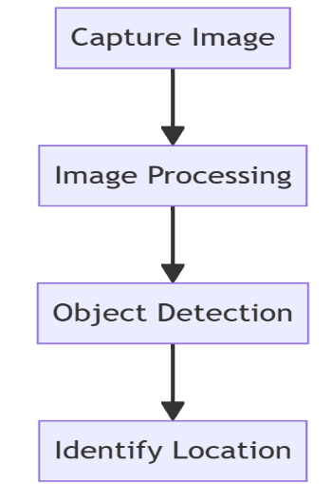
Figure4- 2:System Process

Process1: Capture Image
we can explain this process as the following points
- This step involves acquiring images of the desert environment using various sensors such as drones.
- The captured images may include visible light images, thermal images, or multispectral images, depending on the available sensors and the specific requirements of the search and rescue operation.
- Capturing images from different perspectives and at regular intervals can provide comprehensive coverage of the search area and enable better analysis.
Process2: Image Processing
we can explain this process as the following points
- Image processing encompasses various techniques to enhance, analyze, and extract relevant information from the captured images.
- Preprocessing techniques may include noise reduction, contrast enhancement, and geometric correction to improve the quality and accuracy of the images.
- Feature extraction methods can be applied to identify key characteristics such as terrain features, heat signatures, and potential objects of interest within the images.
- Image segmentation may also be performed to partition the images into meaningful regions or objects for further analysis.
Process3: Object Detection
we can explain this process as the following points
- Object detection is the process of identifying and locating specific objects within the processed images.
- In the context of search and rescue in the desert, the primary objective is to detect and localize humans who may be lost or in distress.
- Object detection algorithms, such as deep learning-based models (e.g., convolutional neural networks), can be trained to recognize human figures based on visual cues such as shape, size, and context.
- The output of the object detection step typically includes bounding boxes or polygons around detected humans, along with confidence scores indicating the likelihood of correct detection.
Process4: Identify Location
we can explain this process as the following points
- After detecting humans in the desert environment, the next step is to determine their precise geographical coordinates.
- Geolocation techniques such as GPS or georeferencing can be used to accurately determine the latitude and longitude of the detected objects.
- Additionally, contextual information from the captured images, such as landmarks or geographical features, can help refine the location estimation.
- Integrating location information with the output of the object detection step provides search and rescue teams with actionable intelligence to plan and execute rescue operations effectively.

4.3 Proposed algorithm
Spacing between title of subsection and first line of text is 1.5 lines. Spacing between the last line of text and table is 1.5 lines.
YOLOv3 is a fully convolutional neural network made up of 1×1 and 3×3 convolution filters. It maintains a fast-processing speed while providing remarkable accuracy for objects of varying sizes. Figure3-2 shows the network architecture of YOLOv3 [18].
YOLOv3 has been verified in different works targeting various applications. The obtained results show that YOLOv3 insures real- time detection while achieving remarkable accuracy and precision.
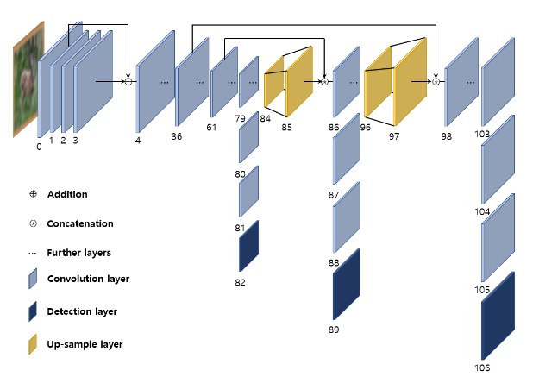
Figure4-3:The network architecture of YOLOv3[18]

In our work, we experimented YOLOv3 to detect humans in aerial images. The obtained results show its relevance in detecting human bodies in real-time while providing acceptable accuracy.

4.4 software environment
The project is implemented by python language. Python is one of effective language which used in different application such as deep learning and machine learning. it is easy to learn and easy to use so it prefers by many developers.

Figure4- 1:Python logo

TensorFlow is one of the most library which used in deep learning, it used to deal with graph and diagrams in python, it applies many of complex operation which used in graph as matrix operation [19].
Keras is one of important library which used in python in different application such as TensorFlow, Theano and CNTK. Keras use in many deep learning projects for different reasons such as:
- Takes into consideration simple and quick prototyping (through ease of use, measured quality, and extensibility).
- Supports both convolutional systems and intermittent systems, just as mixes of the two.
- Runs flawlessly on CPU and GPU.
Keras is an open-source neural-arrange library written in Python. It is equipped for running on TensorFlow, Microsoft Cognitive Toolkit, R, Theano, or PlaidML. Intended to empower quick experimentation with profound neural systems, it centers around being easy to use, secluded, and extensible. It was created as a major aspect of the exploration exertion of task ONEIROS (Open-finished Neuro-Electronic Intelligent Robot Operating System), and its essential creator and maintainer is François Chollet, a Google engineer. Chollet additionally is the creator of the XCeption profound neural system model[20].

4.5 Summary
Our project implementation follows a systematic approach comprising four essential steps: image capture, image processing, object detection, and location identification. Utilizing the robust YOLOv3 algorithm, renowned for its prowess in object identification, we aim to enhance the effectiveness of search and rescue operations in desert environments by reliably detecting humans within aerial images. Furthermore, system design's emphasis on quality ensures the creation of a software system that is not only reliable but also efficient, empowering our intelligent search and rescue system to perform optimally in critical situations.

CHAPTER 5

RESULTS

5.1 project interface
There are the main interfaces in our project, the user can select which algorithm needed to apply in the project for person detection, we provided two selections of algorithm: CNN, and YOLO algorithms.
Home page
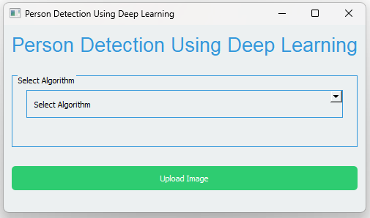
Figure5- 1:Home page

CNN algorithm page
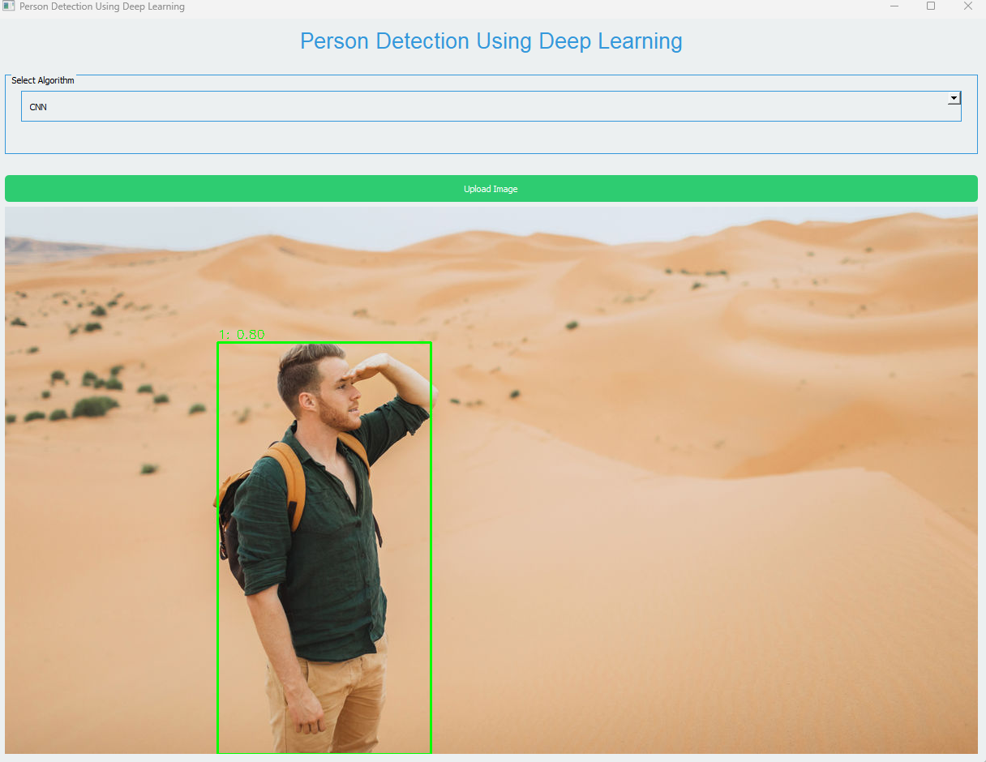
Figure5- 2: CNN algorithm page

YOLO algorithm page
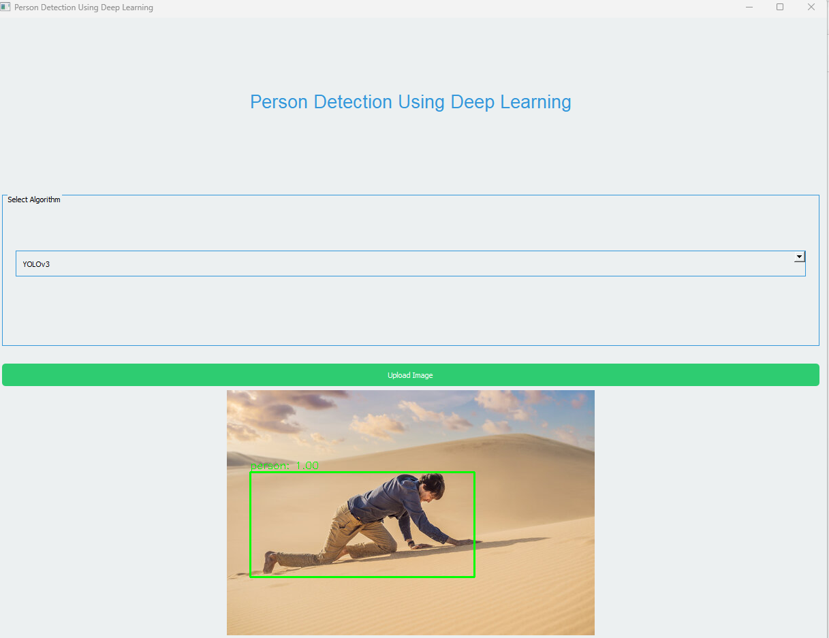
Figure5- 3:YOLO algorithm page
The results show high accuracy for CNN and YOLO algorithms, but the main deferent between them is related to execution time. We notice that CNN algorithm needs more execution time than YOLO algorithm, so we can consider that CNN cost is higher than YOLO cost according to execution time and process.

5.2 project database
We used COCO dataset for our project, COCO is a visual dataset with significant applications in computer vision. In this tutorial, we will go over all you need to know about the popular Microsoft COCO dataset, which is commonly used for machine learning projects. Learn what MS COCO can achieve and how it differs from other COCO alternatives, such as Google's OID (Open Images Dataset). [21].

List of the COCO Object Classes
The COCO dataset classes for object detection and tracking include the following pre-trained 80 objects:
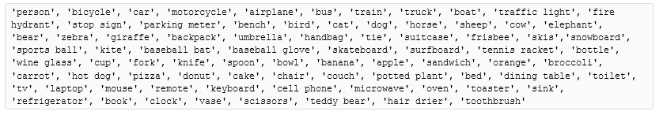
Figure5- 4:List of the COCO Object Classes

5.3 project code
We using command shell to run the project, and we use python to write the project code, there are some figures for our project code.

Import libraries code
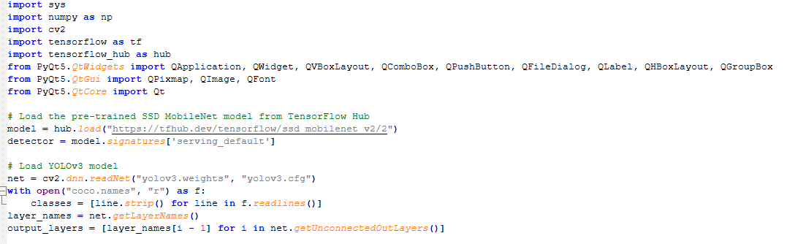
Figure5- 5:Import libraries code

Interface code
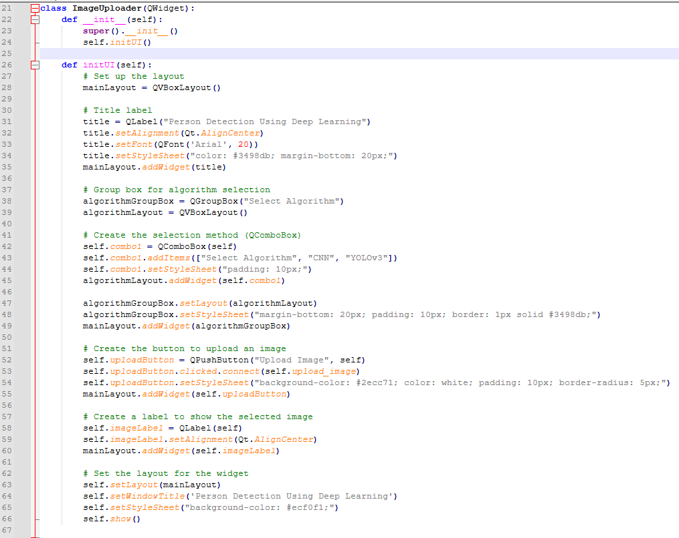
Figure5- 6:Interface code

Upload image code
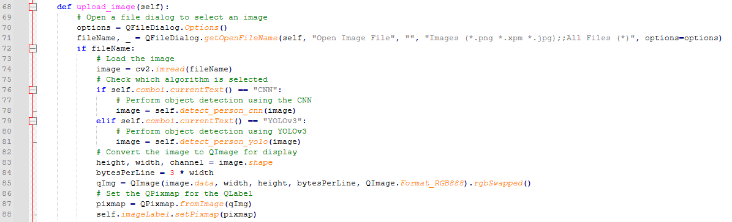
Figure5- 7:Upload image code

CNN algorithm code
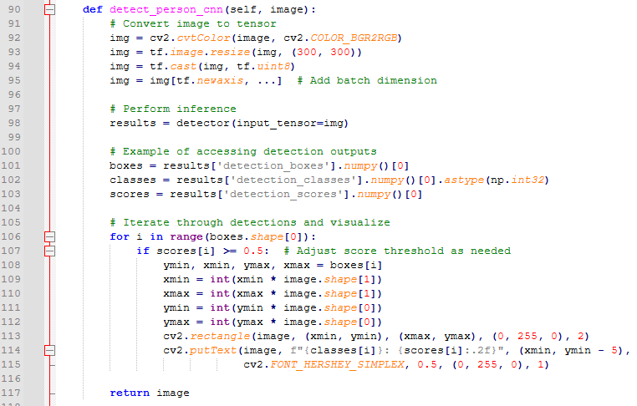
Figure5- 8:CNN algorithm code

YOLO code
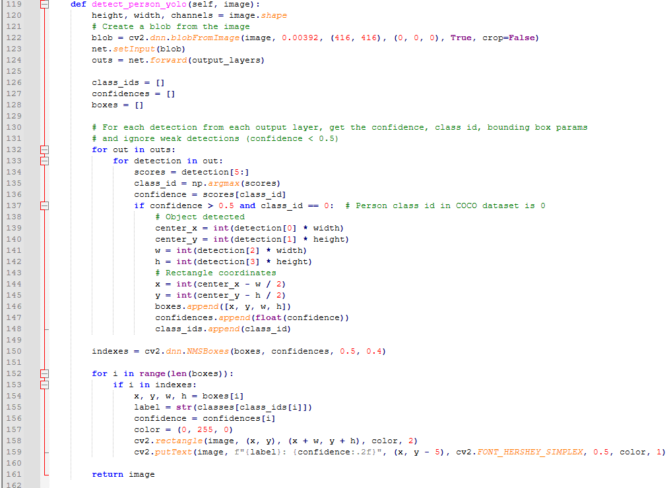
Figure5- 9:YOLO code

CHAPTER 6

CONCLUSION AND RECOMMENDATION

6.1Conclusion
In conclusion, leveraging artificial intelligence (AI) and drones for search and rescue operations in desert environments presents a promising solution to the critical challenge of locating lost individuals efficiently and effectively.
We identify the project design, so we have clear information about system design and system architecture. in addition, we have concept information about using dataset in our project, so we will use supervised dataset for training our system, hence it is easier learning than un-supervised dataset.

6.2 Students reflection
- This project immersed me in the critical challenges of desert search and rescue. Balancing the vastness of desert landscapes with the precision of AI algorithms proved both daunting and exhilarating. Collaborating with peers underscored the power of collective innovation.
- Through this experience, I've gained a deeper appreciation for the intersection of technology and humanitarianism. I'm inspired by the potential of our work to save lives and make a meaningful impact.

Recommendation

As next step, we will learn how improve our project as practical way, so we need to add more features for our project such as adding other algorithms and test the accuracy and execution time for them.

REFERENCES

[1] Schedl, D. C., Kurmi, I., & Bimber, O. (2020). Search and rescue with airborne optical sectioning. Nature Machine Intelligence, 2(12), 783-790.‏
‏

[2] Rizk, M., Slim, F., & Charara, J. (2021, December). Toward AI-assisted UAV for human detection in search and rescue missions. In 2021 International Conference on Decision Aid Sciences and Application (DASA) (pp. 781-786). IEEE.‏

[3] Albanese, A., Sciancalepore, V., & Costa-Pérez, X. (2021). SARDO: An automated search-and-rescue drone-based solution for victims localization. IEEE Transactions on Mobile Computing, 21(9), 3312-3325.‏

[4] Lowe, D. G. (2004). Distinctive image features from scale-invariant keypoints. International journal of computer vision, 60, 91-110.‏

[5] Felzenszwalb, P. F., Girshick, R. B., McAllester, D., & Ramanan, D. (2009). Object detection with discriminatively trained part-based models. IEEE transactions on pattern analysis and machine intelligence, 32(9), 1627-1645.‏

[6] Girshick, R., Donahue, J., Darrell, T., & Malik, J. (2014). Rich feature hierarchies for accurate object detection and semantic segmentation. In Proceedings of the IEEE conference on computer vision and pattern recognition (pp. 580-587).‏

[7] Uijlings, J. R., Van De Sande, K. E., Gevers, T., & Smeulders, A. W. (2013). Selective search for object recognition. International journal of computer vision, 104, 154-171.‏

[8] Dominguez, M. H., Nesmachnow, S., & Hernández-Vega, J. I. (2017, August). Planning a drone fleet using artificial intelligence for search and rescue missions. In 2017 IEEE XXIV International Conference on Electronics, Electrical Engineering and Computing (INTERCON) (pp. 1-4). IEEE.‏

[9] Amer, K., Samy, M., Shaker, M., & ElHelw, M. (2021, January). Deep convolutional neural network based autonomous drone navigation. In Thirteenth International Conference on Machine Vision (Vol. 11605, pp. 16-24). SPIE.‏

[10] Burke, C., McWhirter, P. R., Veitch-Michaelis, J., McAree, O., Pointon, H. A., Wich, S., & Longmore, S. (2019). Requirements and limitations of thermal drones for effective search and rescue in marine and coastal areas. Drones, 3(4), 78.‏

[11] Tang, J., Duan, H., & Lao, S. (2023). Swarm intelligence algorithms for multiple unmanned aerial vehicles collaboration: A comprehensive review. Artificial Intelligence Review, 56(5), 4295-4327.‏

[12] Stolfi, D. H., Brust, M. R., Danoy, G., & Bouvry, P. (2020). Emerging inter-swarm collaboration for surveillance using pheromones and evolutionary techniques. Sensors, 20(9), 2566.‏

[13] https://images.app.goo.gl/cFZMYSfjyeKgtVEV8.‏

[14] Caputo, S., Castellano, G., Greco, F., Mencar, C., Petti, N., & Vessio, G. (2021, December). Human detection in drone images using yolo for search-and-rescue operations. In International Conference of the Italian Association for Artificial Intelligence (pp. 326-337). Cham: Springer International Publishing.‏

[15] Ren, S., He, K., Girshick, R., & Sun, J. (2016). Faster R-CNN: Towards real-time object detection with region proposal networks. IEEE transactions on pattern analysis and machine intelligence, 39(6), 1137-1149.‏
[16] Masurekar, O., Jadhav, O., Kulkarni, P., & Patil, S. (2020). Real time object detection using YOLOv3. International Research Journal of Engineering and Technology (IRJET), 7(03), 3764-3768.‏

[17] Redmon, J., & Farhadi, A. (2017). YOLO9000: better, faster, stronger. In proceedings of the IEEE conference on computer vision and pattern recognition (pp. 7263-7271).‏

[18] Kim, S., & Kim, H. (2021). Zero-centered fixed-point quantization with iterative retraining for deep convolutional neural network-based object detectors. IEEE Access, 9, 20828-20839.‏
[19] Raschka, S., & Mirjalili, V. (2019). Python machine learning: Machine learning and deep learning with Python, scikit-learn, and TensorFlow 2. Packt publishing ltd.‏

[20] Zafar, I., Tzanidou, G., Burton, R., Patel, N., & Araujo, L. (2018). Hands-on convolutional neural networks with TensorFlow: Solve computer vision problems with modeling in TensorFlow and Python. Packt Publishing Ltd.‏

[21] https://viso.ai/computer-vision/coco-dataset/

